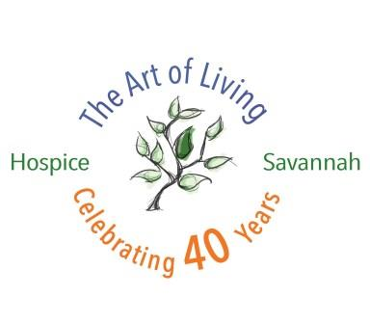
2019 Hospice Savannah Golf Tournament presented by
The Landings Club’s Plantation Course

Friday, September 6, 2019

Lunch followed by 1:00 p.m. shotgun start
Platinum Sponsorship $5,000
Pre-Event Benefits: Company name included on tournament printed materials, on social media, and on pre and post-event ads. (Logos needed by August 19)
Day of Event Benefits: Company may field two four-man teams. Company’s logo on the step-and-repeat banners; Co-branded water bottles with company logo/Hospice Savannah Logo; Recognized with color logo on the Platinum Banner; Company’s promotional materials placed in all participants’ gift bags; Logo on a tee sign and on thank you board at sign-in table; Company name and logo on lunch table tents and recognition on golf cart signage and rule sheet; Sponsorship company tent on the course (provided by Hospice Savannah).
Gold Sponsorship $2,500
Pre-Event Benefits: Company name included on tournament printed materials, on social media, and on pre and post-event ads. (Logos needed by August 19).
Day of Event Benefits: Company may field two four-man teams. Recognized with color logo on the Gold Banner; Company’s promotional materials placed in all participants’ gift bags; Logo on a tee sign and on thank you board at sign-in table; Company name and logo on lunch table tents and recognition on golf cart signage and rule sheet; Option to host a company tent on the course (provided by Hospice Savannah).
Silver Sponsorship $1,000
Pre-Event Benefits: Company name included on tournament printed materials and featured in pre and post-event ads. (Logos needed by August 15).
Day of Event Benefits: Company may field one four-man team. Recognized with color logo on the Silver Banner; Company’s promotional materials placed in all participants’ gift bags; Logo on a tee sign and on thank you board at sign-in table; Company name and logo on lunch table tents and recognition on golf cart signage and rule sheet.
Scoreboard Sponsorship (only one available) $1,000
Pre-Event Benefits: Company name included on tournament printed materials and featured in pre and post-event ads. (Logos needed by August 19).
Day of Event Benefits: Company may field one four-man team. Recognized with color logo on the Silver Banner and on a tee sign on course. Lights (provided by sponsor) and logo on the official scoreboard.
Bronze Sponsorship $600

Day of Event Benefits: Company may field one four-man team. Logo included on golf tournament materials and on a tee sign on course. (Logos needed by August 19).

Tee Sponsorship (Company name and/or in memory of) $100

Day of Event Benefits: Tee sign on course.

Help us support your friends, families and neighbors in our community!

- Platinum sponsor $5,000
- Gold sponsor $2,500
- Silver sponsor $1,000
- Scoreboard sponsor (one only) $1,000
- Bronze sponsor $600
- Tee sponsor $100

The Landings Club’s Plantation Course

Friday, September 6, 2019

Lunch followed by 1:00 p.m. shotgun start

Company Name Contact Person

Phone number Email address

Mailing address

Team registration:

Golfer One Handicap Email address

Golfer Two Handicap Email address

Golfer Three Handicap Email address

Golfer Four Handicap Email address

Please return this form to:
Ophelia Rodriguez, Annual Giving Specialist
Hospice Savannah Foundation, Inc., P.O. Box 13190, Savannah, GA 31416
Phone: 912.629.1027
Email: orodriguez@HospiceSavannah.org

An invoice will be sent to you upon receipt.
Thank you for your support!

